

 Hash Your First Block – Blockchain Basics and Setup.

**Objective/Aim:**  
  
 To learn the basics of blockchain hashing by creating and hashing the first block using the EGETH online blockchain

simulator.

**Apparatus/Software Used:**

* Laptop
* Egeth
* Web browser

**Theory/Concept:**

**What is blockchain?**

A blockchain is a sequence of linked blocks where each block contains:

* Block Index – Position in the chain.
* Timestamp – When the block was created.
* Data – Transaction or stored information.
* Previous Hash – Hash of the preceding block.
* Hash – Unique fingerprint of the current block.

These hashes are generated using cryptographic algorithms (e.g., SHA-256), ensuring:

* Data Integrity – Any change alters the hash.
* Immutability – Previous records cannot be altered without breaking the chain.
* Security – Protects against tampering.

**Avalanche Effect** – Even a small change in data completely changes the block’s hash.

**Key Features of Blockchain**

* Decentralization – No single authority; data is shared across nodes.
* Transparency – Transactions are visible and verifiable by all.
* Immutability – Data cannot be changed once recorded.
* Security – Protected by cryptography and consensus rules.



**Procedure:**

|  |  |  |  |
| --- | --- | --- | --- |
|  |  |  |  |
|  |  |  |  |
|  |  |  |  |
|  |  |  |  |
|  |  |  |  |
|  |  |  |  |
|  |  |  |  |

Step 1: Go to https://andersbrownworth.com/blockchain in your browser.

Step 2: In **Block 1**, fill in the *Data* field and keep the **Previous Hash** as 0.

Step 3: Click the **Mine** button. The system will calculate a valid hash and display it.

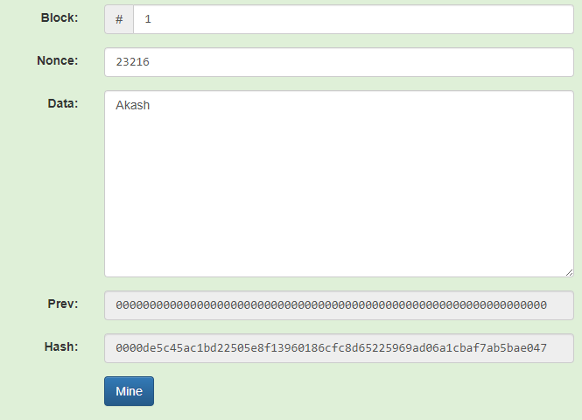 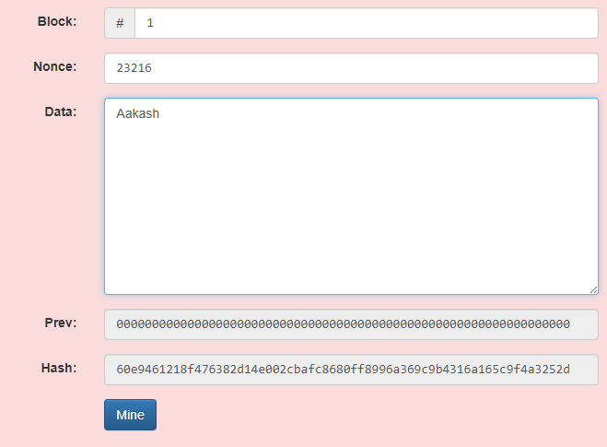

**Valid block’s hash after mining the data invalid block’s hash due to change in the input data (avalanche effect)**

* Any change in data will require re-mining

**Observation Table:**



Prev hash: 0000000000000000000000000000000000000000000000000000000000

Hash: 0000de5c45ac1bd22505e8f13960186cfc8d65225969ad06a1cbaf7ab5bae047

Hash (due to change in data): 60e9461218f476382d14e002cbafc8680ff8996a369c9b4316a165c9f4a3252d

Block no. 1

Nounce:23216



